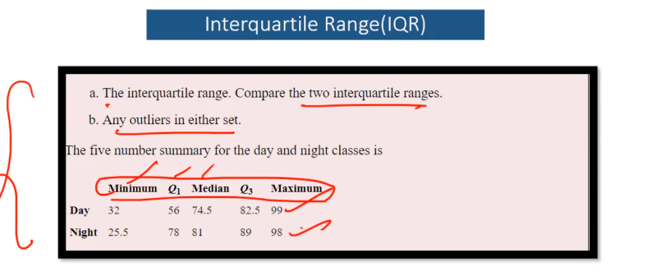

**DAY**

IQR = Q3 - Q1

IQR = 82.5 - 56

IQR = 26.5

1.5 * IQR = 39.75

Lesser Range of Outlier = Q1 - 1.5 * IQR

= 56 - 39.75

= 16.25

Greater Range of Outlier = Q3 + 1.5 * IQR

= 82.5 + 39.75

= 122.25

Day Lesser Outlier = Check the Lesser Range of Outlier with the Minimum

= There is NO Lesser Outlier for Day(There is no value less than 16.25)

Day Greater Outlier = Check the Greater Range of Outlier with the Minimum

= There is NO Greater Outlier for Day(There is no value greater than 122.25)

**Conclusion:**

**There is NO Potential Outlier for the Day dataset**

**NIGHT(Potential Outlier in Lesser Range)**

IQR = Q3 - Q1

IQR = 89 - 78

IQR = 11

1.5 * IQR = 16.5

Lesser Range of Outlier = Q1 - 1.5 * IQR

= 78 - 16.5

= 61.5

Greater Range of Outlier = Q3 + 1.5 * IQR

= 89 + 16.5

= 105.5

Night Lesser Outlier = Check the Lesser Range of Outlier with the Minimum

= There is a Potential Lesser Outlier for Night(There is a value less than 61.5 )

25.5 is the potential outlier

Night Greater Outlier = Check the Greater Range of Outlier with the Maximum

= There is NO Greater Outlier for Night(There is no value greater than 105.5)

**Conclusion:**

**There is a Potential Outlier for the Night dataset in the Lesser Range is 25.5**